Time, Money, and Health acceleration

October 18th, 2025

Table of Contents

Executive Summary | 2
The Lineup | 3
BHAGs | 5
Who do you dream about? | 6
168 hours | 7
Money Matters | 8
Finding “Joy” each day | 9
Secrets to reaching every goal you set for yourself – Dr. CJ Mertz | 10
My Monday “To-Do” list | 11

Executive Summary
Why am I here this weekend?

The purpose of this weekend is to dig deep into my own personal feelings and relationship with myself, others, and pivotal factors or influences around me that can impact my success or failure. These include healthy or harmful relationships, time management, my relationship with money, how I deal with challenges, and my own self-esteem relating to these factors. What is my “success plan?”
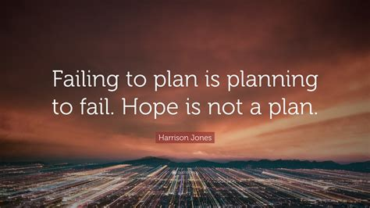
What relationships am I nurturing? Which relationships are building me up and which are causing me harm? Am I attracting the partner of my dreams?
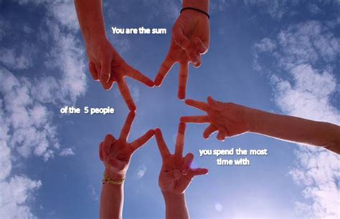

The line up

What is my relationship with money and “true wealth?” Do I have a healthy relationship with money. Do I live in a way to attract more true wealth my way?
** Money is only 1 of 5 components of wealth, according to Garrett Gunderson.

Garrett on YouTube: https://www.youtube.com/watch?v=VgDHx40637o

Time. It is important to recognize that we ALL have the same 168 hours per week. Millionaires and the homeless are equal here. So, what makes successful people different? Ask yourself, am I doing or can I change what I am doing, to better utilize the “gift of time” I have been given. Can I leverage my time better to increase my happiness, healthy relationships, personal health, wealth, and goal accomplishments?
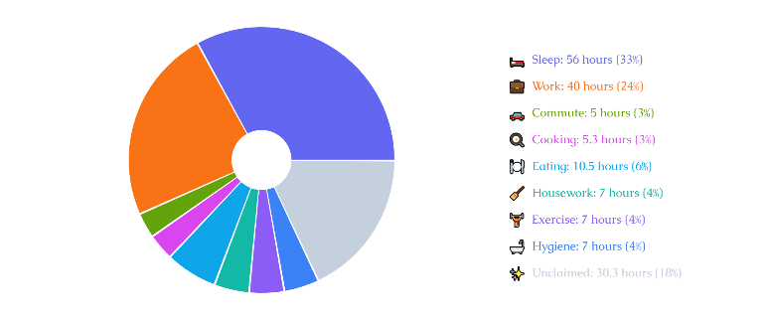

There is no question, life throws us curveballs and we can get derailed from having a happy day every day. How do I find “Joy” during the trials that life throws my way. I understand that I can’t always control WHAT happens in my life, but I can ALWAYS CONTROL how I choose to respond.
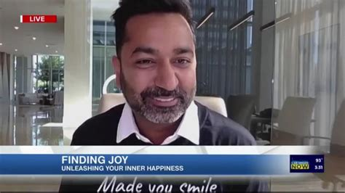

Once I decide who I want to be, who I want to spend time with, and who and what I want to attract into my life, then I guess I better set some goals. But how do I really leverage or hold myself accountable to guarantee I can reach my goals? Coach – Dr. CJ Mertz has some “Secret (hot) Sauce” to help you reach every goal you are serious about.


My Big Harry Audacious Goals (BHAG)

In 2002 I met Mark Vicor Hansen, the creator and author of the “Chicken Soup for the Soul” books. I got two powerful things out of that weekend. From the stage he had us all write down our top 50 craziest goals for life. We later met for lunch where I learned about the “Friendly Franklin” idea, for changing my relationship with money…but we will save that for later. Back to BHAG. I wrote down these goals, including “living and practicing in a foreign country,” which I didn’t even take myself seriously when I wrote it. (I also wrote down, travel to space like an astronaut, haha!). I put this list in some drawer and forgot about it. Decades later, going though some boxes when we were moving from one house in South Jordan to another, I somehow came across this list. I was SHOCKED how many I had accomplished. I am going to challenge you to write down your top 50 to 100 BHAGs.


___________________ ____________________ ____________________
___________________ ____________________ ____________________
___________________ ____________________ ____________________
___________________ ____________________ ____________________

___________________ ____________________ ____________________
___________________ ____________________ ____________________
___________________ ____________________ ____________________
___________________ ____________________ ____________________
___________________ ____________________ ____________________
___________________ ____________________ ____________________
___________________ ____________________ ____________________
___________________ ____________________ ____________________
___________________ ____________________ ____________________
___________________ ____________________ ____________________
___________________ ____________________ ____________________
___________________ ____________________ ____________________
___________________ ____________________ ____________________
___________________ ____________________ ____________________
___________________ ____________________ ____________________
___________________ ____________________ ____________________
___________________ ____________________ ____________________
___________________ ____________________ ____________________
___________________ ____________________ ____________________
Great Job!!

Who do I dream about?


Have you “invested” the time thinking about, visualizing, making a list of characteristics you want or expect in your Life-Partner to have or share with you? If there is one exercise worth taking a few minutes to do…this, is it! In a few sentences, or with a list of just words that describe what you are looking for in a partner, help yourself, help the Universe attract that right person in your life.

Notes: (need more space? Write on the back of this page.) (Already Married? What can you do to better serve your spouse?)

_______________________________________________________________________

________________________________________________________________________

________________________________________________________________________

________________________________________________________________________

________________________________________________________________________

________________________________________________________________________

________________________________________________________________________


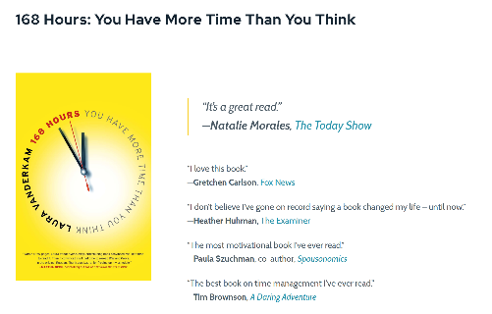
Time Management
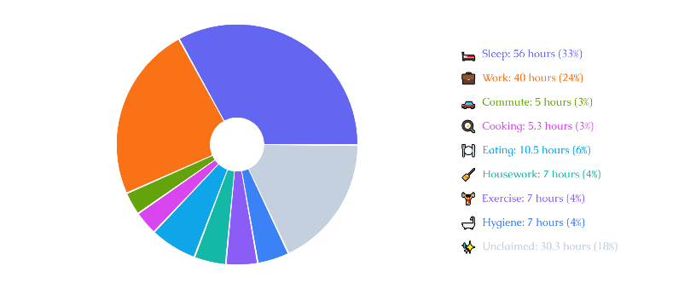

Notes: _________________________________________________________________

________________________________________________________________________
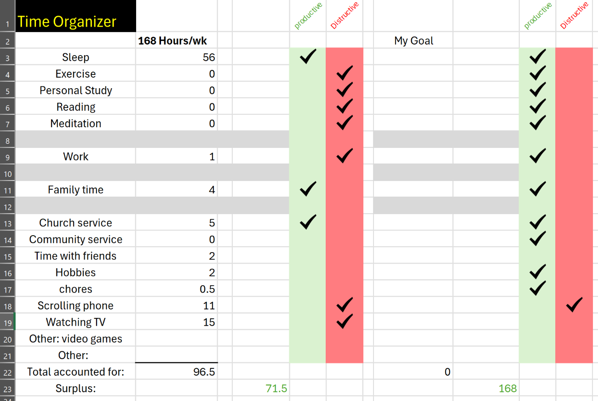

https://lauravanderkam.com/start-here/

Money and Wealth

Notes: _________________________________________________________________

________________________________________________________________________

________________________________________________________________________

________________________________________________________________________

________________________________________________________________________

________________________________________________________________________

________________________________________________________________________

________________________________________________________________________

________________________________________________________________________

________________________________________________________________________

________________________________________________________________________

________________________________________________________________________


Finding or Making Joy

Notes: _________________________________________________________________

________________________________________________________________________

________________________________________________________________________

________________________________________________________________________

________________________________________________________________________

________________________________________________________________________

________________________________________________________________________

________________________________________________________________________

________________________________________________________________________

________________________________________________________________________

________________________________________________________________________

________________________________________________________________________

Blackbelt Goal Techniques

Notes: _________________________________________________________________

________________________________________________________________________

________________________________________________________________________

________________________________________________________________________

________________________________________________________________________

________________________________________________________________________

________________________________________________________________________

________________________________________________________________________

________________________________________________________________________

________________________________________________________________________

________________________________________________________________________

________________________________________________________________________
Summary “to-do” plan

You can always review ALL of the things discussed today. And the people you met genuinely care about you and are available for you to reach out for further friendship, love, counsel, mentorship, coaching, etc. Don’t waste the opportunity of increasing positivity from people who care about you. You are loved! And you are loved by some pretty great people!!

Jot down below the top 2 or 3 things you want to work on improving this week and over the next 30 days.

Notes: _________________________________________________________________

________________________________________________________________________

________________________________________________________________________

________________________________________________________________________

________________________________________________________________________

________________________________________________________________________

________________________________________________________________________

________________________________________________________________________

________________________________________________________________________



